**SECTION A**

**Attempt** only three **questions in this section.**

1. Define the following terms: (@01 mark)
2. **Bond energy.**
3. **Enthalpy of reaction.**
4. **Enthalpy of neutralization**.
5. Use the following thermo chemical data to calculate the enthalpy of the equation. (03 marks)



* Enthalpy of formation of carbon dioxide = **-394KJ/mol**
* Enthalpy of formation of water = **-286KJ/mol**
* Enthalpy of formation of ethane = **+85KJ/mol**

1. Explain each of the following observations: (@03 marks)
2. The **enthalpy of neutralisation** of a **weak acid** with a **strong** **base** is **less** than that between a **strong acid** with a **strong base**.
3. The **bond energies** of the halogens are in the order of:



1. During the experiment to determine the enthalpy of neutralisation between hydrochloric acid and sodium hydroxide solution is **25.0cm3** of **1.0M** hydrochloric acid was pipetted in to a plastic beaker and titrated with **1.0M** sodium hydroxide solution from the burette. The temperature of the solution was recorded every after addition of the sodium hydroxide solution in the table below.



1. Plot a **graph of volume** of sodium hydroxide solution added against **temperature change**. (03 marks)
2. Determine the **maximum temperature change** from the graph. (02 marks)
3. Determine **the volume** of the sodium hydroxide solution at the end point. (01 mark)
4. Calculate the **enthalpy of neutralisation** of the reaction if **4.18KJ/mol/C/kg** is the specific heat capacity. (03 marks)
5. Zinc is **a d-block** element.
6. (i).Write the **electronic configuration of Zinc**. (01 mark)
7. (ii).State the **common oxidation state** of zinc. (01 mark)
8. Briefly explain why **zinc is not a transition metal**. (02 marks)
9. (i).List down **three chemical properties of zinc** that are not shared with Group (II) A metals. (03 marks)
10. (ii).List down **three chemical properties of zinc** that are similar to those of group (II) A metals. (03 marks)
11. With the help of **equations**, **describe the reaction of zinc** with: (@03 marks)

* Sulphuric acid.
* Sodium hydroxide solution.

1. Zinc metal is used in some organic reactions. (@02 marks)
2. Suggest two organic chemistry reactions in which zinc metal is used as catalyst.
3. Suggest two organic chemistry reactions in which a salt of zinc is used.
4. Ethylamine, dimethylamine and ammonia are weak bases when in aqueous solution.
5. (i).Arrange the compounds in order of increasing basic strength. (01 mark)
6. (ii).Suggest a reason why the basic strength is in that order. (03 marks)
7. (i).Name a reagent that could be used to identify the functional group of the bases. (01 mark)
8. (ii).State what is observed when each of the bases is separately treated with the named reagent. (01 mark)
9. Using equations and showing the necessary conditions, show how:
10. Dimethylamine could be prepared from ethanol. (04 marks)
11. Ethylamine could be converted to propanoic acid. (04 marks)
12. (i).Name the reagent that could be used to distinguish between the bases. (01 mark)
13. (ii).State what is observed when each of the bases is separately treated with the name reagent. (02 marks)
14. (iii).Write the equation for the reaction that took place in each case. (02 marks)
15. Methanoic acid and ethanoic acid are weak organic mono basic acids.
16. (i).What is meant by the term mono basic acid? (01 mark)
17. (ii).Write an equation for the ionization of methanoic acid. (01 mark)
18. (iii).Write an expression for the ionization constant, ka for methanoic acid. (01 mark)
19. **25.0cm3** of **0.1M** methanoic acid solution was reacted with **50.0cm3** of **0.05M** sodium hydroxide solution.
20. Write the equation for the reaction that took place. (01 mark)
21. Calculate the **pH** of the resultant solution. (04 marks)

(ka methanoic acid = 1.77 X 10-4)

1. Explain why the pH of the resultant solution is not equation to 7. (02 marks)
2. Name a reagent that could be used to distinguish between methanoic and ethanoic acid and state what is observed in each case when each is separately treated with the named reagent. (03 marks)
3. To **200.0cm3**of **0.075M** ethanoic acid was added to **1.23g** of sodium ethanoate to make a solution.
4. Calculate the **pH** of the resultant solution. (03 marks)
5. **10.0cm3** of **0.1M** hydrochloric acid was added to the resultant solution in (d) above. Calculate the change in **pH** of the resultant solution. (04 marks)

**SECTION b**

**Attempt** only two **questions in this section.**

1. Water (**100°C**) and nitric acid (**86°C**) when mixed form a miscible liquid mixture that deviates positively from Raoult’s law.
2. Explain why the mixture deviates positively from Raoult’s law. (02 marks)
3. Draw a well labeled temperature composition diagram for the mixture. (04 marks)

(Azeotropic mixture composition and boiling point are **68%** nitric acid and **120.5°C**)

1. Describe the shape of the diagram. (05 marks)
2. Describe what happens when a solution containing **80%** nitric acid was fractionally distilled. (04 marks)
3. (i).Calculate the molarity of nitric acid in the Azeotropic mixture. (04 marks)
4. (ii).Give one method that could be used to increase the percentage of nitric acid in the Azeotropic mixture. (01 mark)
5. Explain each of the following observations. Use relevant equations where necessary.
6. The boiling point of the solution containing **0.3075g** nitrobenzene in **100.0g** of benzene is the same as that of a solution containing **0.38g** of camphor in **100.0g** of benzene. (04 marks)
7. The atomic radius of group (II) A metals increases down the group. (03 marks)
8. An aqueous solution of aluminium chloride is acidic. (03 marks)
9. Graphite and copper are both conductors of electricity. (04 marks)
10. When concentrated hydrochloric acid was added to an aqueous solution of cobalt (II) chloride, the colour of the solution changed from pink to blue. When the resultant solution was diluted with water, the solution turned from blue to pink. (04 marks)
11. Acidified potassium mangnate (VII) solution when stored for some time, forms brown precipitate. (02 marks)
12. With the help of equations and giving the necessary conditions, show how each of the following conversions could be completed.









1. Ethene reacts with reacts with steam to produce ethanol according to the equation below.



1. State with reason, the effect of each of the following changes on the equilibrium constant value, position of the equilibrium and on the rate of attainment of the equilibrium:
2. Increasing the temperature from **300°C** to **400°C**. (04 marks)
3. Removing the ethanol produced. (02 marks)
4. Adding argon gas at constant pressure. (02 marks)
5. **3.2moles** of ethene were mixed with **4.5moles** of steam and the mixture heated up to **300°C** and at a pressure of **70atmospheres** so as to reach equilibrium. If **5%** of the ethene had reacted with the steam.
6. Determine the **number of moles** of each of the species present at equilibrium. (03 marks)
7. Calculate the **equilibrium constant** value, kp. (03 marks)
8. State the conditions necessary to produce a high yield of ethanol for the reaction. (03 marks)
9. Suggest the optimum conditions for the production of a good yield of ethanol for the industry. (03 marks)

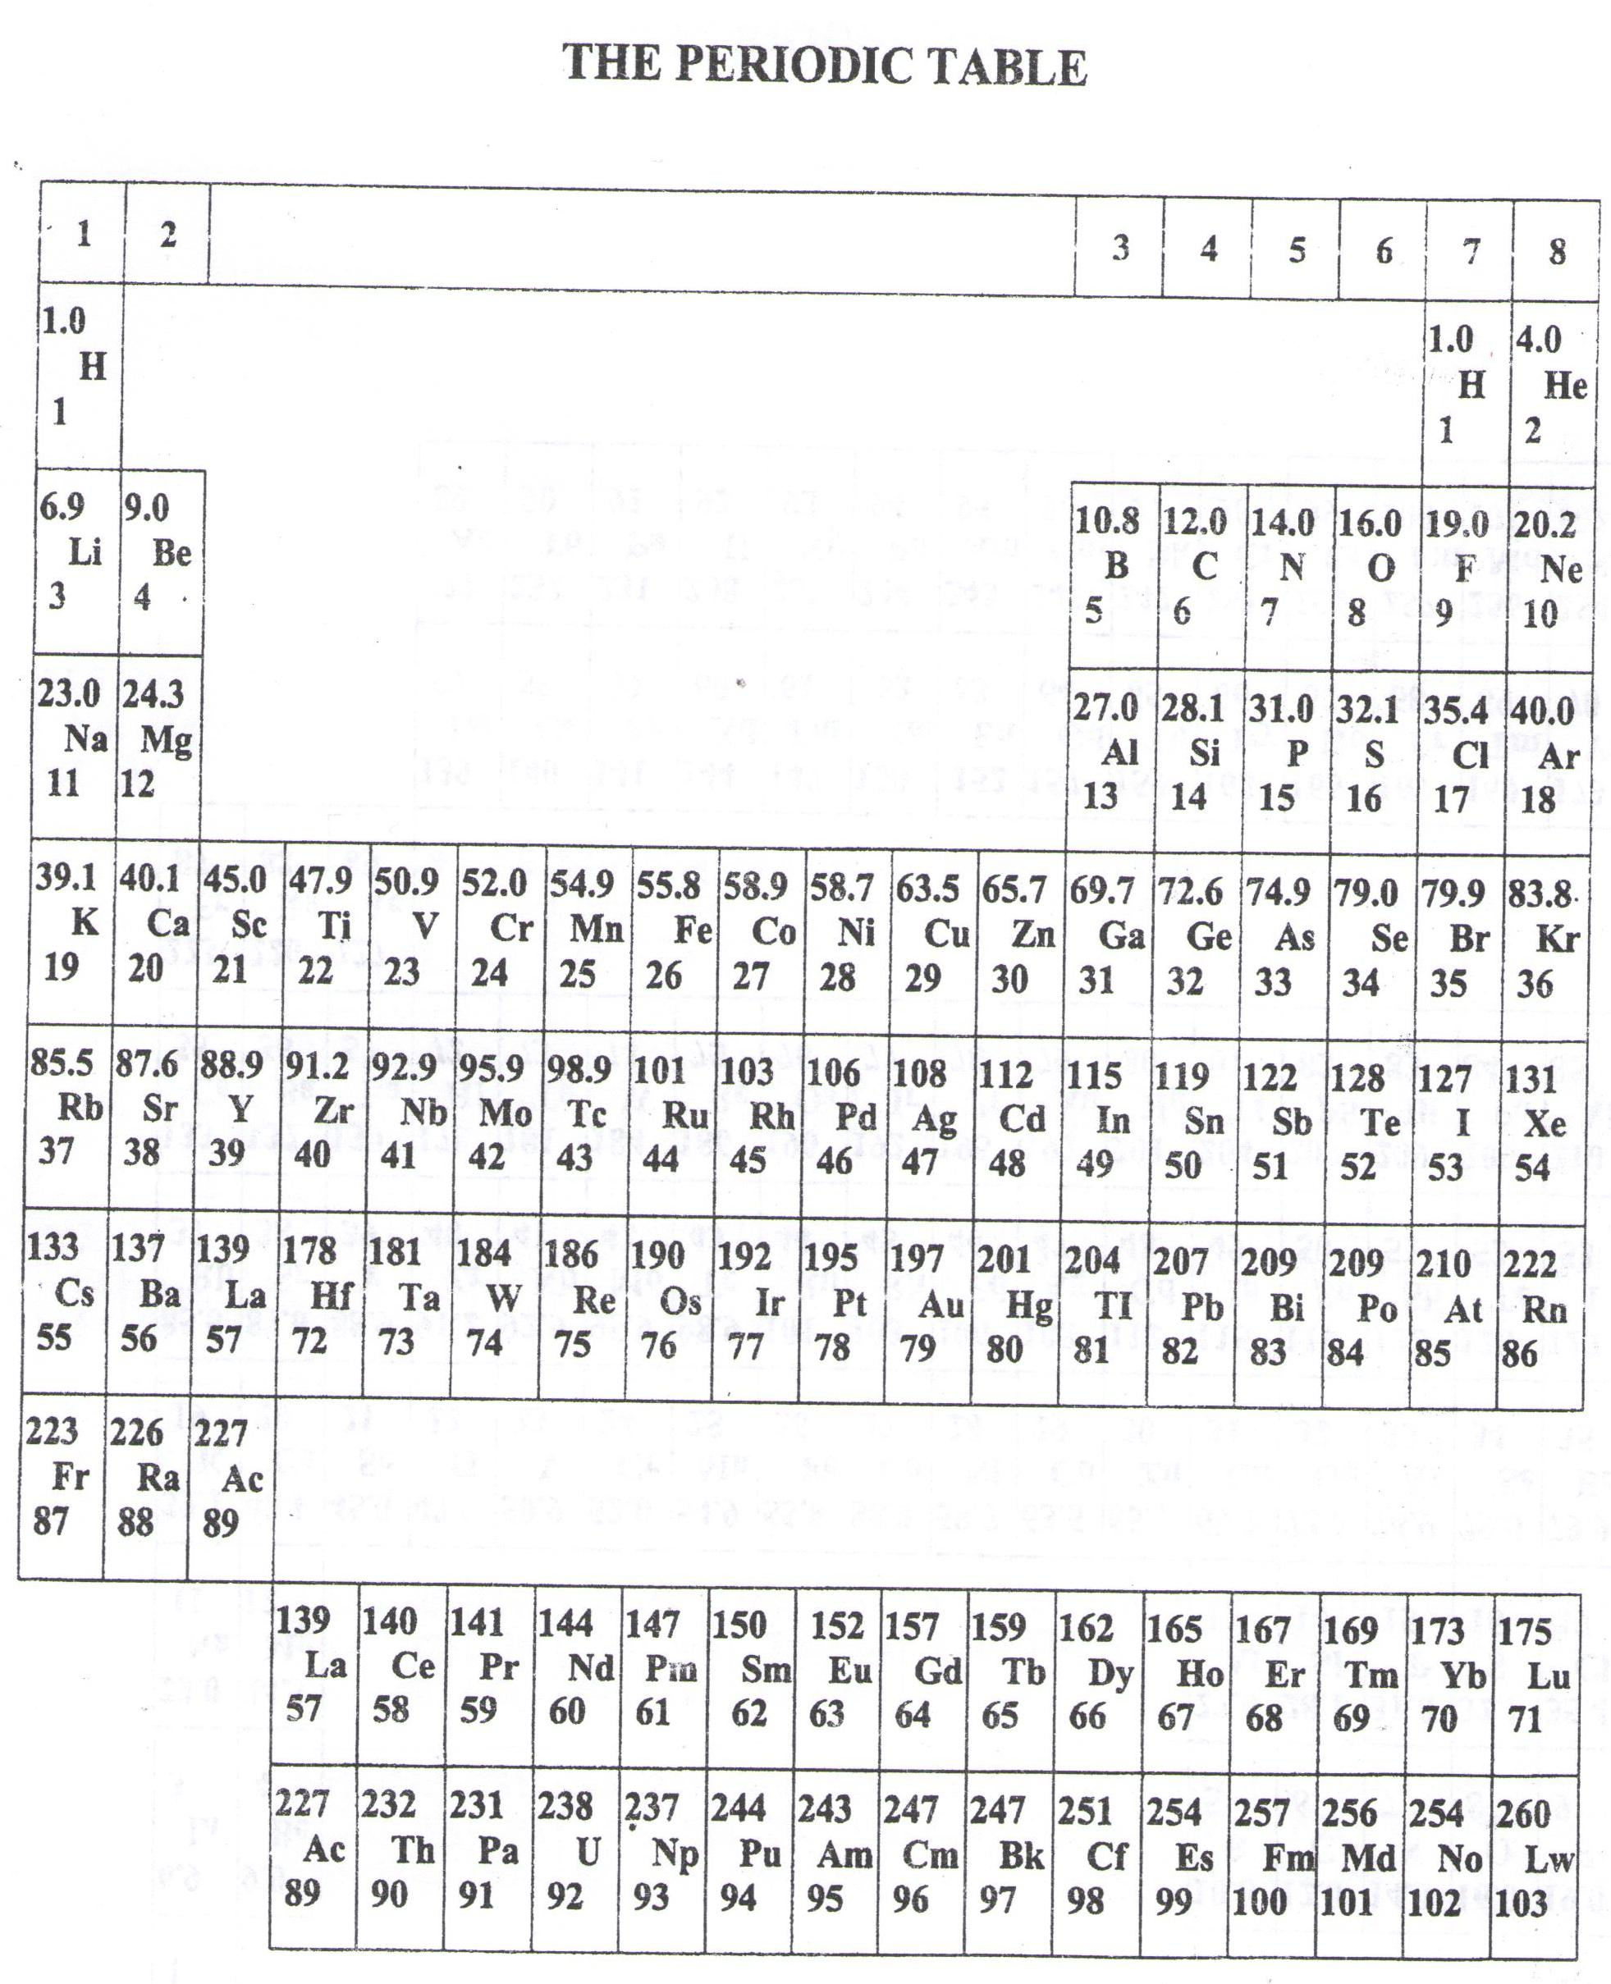

**Success = end**

WELCOME TO SENIOR SIX, YEAR 2023

This is the last page of the printed paper, Page 05